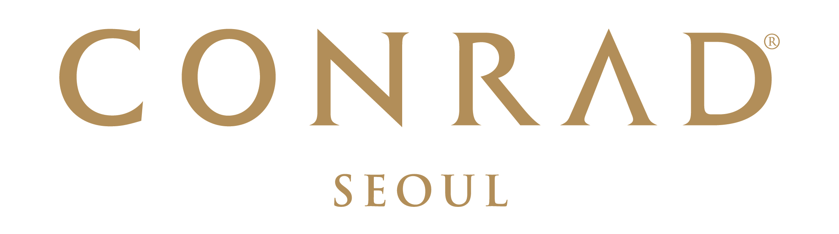  Conrad Seoul Reservation Form  2021 ICOMES  September 02, 2021 ~ September 04, 2021 | Conference Reservation  Conrad Seoul  10 Gukjegeumyung-ro (Yeouido),  Yeongdeungpo-gu, Seoul 07326, Korea  Phone:82-2-6137-7777  Email:  Conradseoul_GroupReservations@hilton.com

RESERVATION DETAILS
Check-in Date: |  |  |  |  |  |  |  | Arrival Flight: |  |  |  |  |  |  |  | ETA:
Check-out Date: |  |  |  |  |  |  |  | Departure Flight: |  |  |  |  |  |  |  | ETD:
Last Name: |  |  |  |  |  |  |  | First Name:
Company: |  |  |  |  |  |  |  | Title:
Booking Contact: |  |  |  |  |  |  |  | Phone:
Fax: |  |  |  |  |  |  |  | Email:
Country: City:
Room Type |  |  |  |  |  |  | Rate |  |  |  |  |  | Number of Rooms |  |  |  | Number of Adults/Children
 | Deluxe Room & Standard Internet for 1Pax (Single) |  |  |  |  |  | KRW 240,000 / (Single) |  |  |  |  |  |  |  |  |  |  |  | /
 | Premium Room & Standard Internet for 1Pax (Single) |  |  |  |  |  | KRW 270,000 / (Single)
 | Queen Corner Premium Room& Standard Internet for 1Pax (Single) |  |  |  |  |  | KRW 285,000 / (Single) |  |  |  |  |  |  |  |  |  |  |  | /
 | Executive Room (River View) with Standard Internet for 1Pax (Single_ Executive Lounge Access) |  |  |  |  |  | KRW 370,000 / (Single) |  |  |  |  |  |  |  |  |  |  |  | /
*This special group rate for 2021 ICOMES is only available upon hotel’s availability.
Preference: |  |  |  | King Twin
Remarks:
- All rates are subject to 10% VAT. No service charge will be applied.
- Additional person charge is KRW 30,000 + 10% VAT for Executive Room.
- Quoted bedroom rates will be offered, based on Hotel’s availability and above rate will be offered for the participant of 2021 ICOMES from September 02th to September 04th, 2021.
- Executive Lounge Benefits: Express check in & out, breakfast at EFL Lounge, Coffee & Tea Service, Evening cocktail & canapés.
TRANSPORTATION
Limousine Transfer Required: |  |  | -Airport pick up & sending service to Conrad Seoul & Incheon International Airport : KRW 175,000 per car (subject to 10% tax)  -Any cancellations or amendments must be received at least 24 hours prior to the expected arrival date |  |  |  |  |  |  |  |  |  |  | Arrival |  |  |  | Departure
* We suggest Airport Limo Bus that runs every 20 mins. Between Incheon International Airport and Conrad Seoul #6030. The rate is KRW 15,000/trip.
RESERVATION GUARANTEE
A credit card guarantee is required at the point of reservation. Reservation can be cancelled or amended 30 days prior to the event date. Entire period of stay will be charged before arrival and incidental will be charged upon check-out.
Guaranteed by: |  |  |  |  | Credit Card:
Cardholder’s Name: |  |  |  |  |  |  |  |  |  | Signature:
Credit Card Number: |  |  |  |  |  |  |  |  |  | Expiry Date:

CANCELLATION POLICY
Reservation can be changed or amended 30 days prior to the event date.
Any cancellations or no shows after 30 days to the event date will be charged the entire period of stay.

TERMS AND CONDITIONS
- To enjoy the room block of 2021 ICOMES, guest rooms will be provided with special rate upon hotel availability.
- Reservation received thereafter will be confirmed subject to availability at prevailing rates.
- Check-in time is after 16:00pm. Check-out time is before 11:00am. For any guests who would like immediate guaranteed access to their rooms prior to 16:00 PM check-in time, the room should be reserved from the previous evening. This will incur an additional one-night accommodation charge.
- This form must reach the hotel no later than 03th August, 2021.
- By providing above mentioned credit card details, cardholder agrees to the reservation guarantee policy.
- Hilton Honors members are entitled to earn hotel points. To enroll, please visit www.hiltonhonors.com.

